**Round Trip Phase Measurement Scheme**

***Temperature Model***

INTRODUCTION

In this analysis we are trying to get a model on basis of Air temperature. There are multiple reflections seen in the data. These reflections are due to 2m and 50m cable used in the experiment. The reflections are modelled based on temperature.

EXPERIMENT

A

B

FLA

LNA

Terminator

Stone Correlator

Splitter

**WRH**

The plus sign in the figure represents the Dual-Polarized feeds and red line is the reference cable, which is 2m SMA cable. The whole experimental setup is described in Doclib# 0496. For the signals through the focal line there is one 2m cable between splitter and outer bulkhead, 2-50m cables to the focal line and back, there is 1 2m cable from outer to inner bulkhead and one 2 m cable from inner bulkhead to correlator. For the reference channel (Red) there is one 2m cable from splitter to inner bulkhead and one from inner bulkhead to correlator. During this setup, cable trays were not covered, the FLAs were not installed. We are using FLA, LNA and terminator as noise source. The 2-50 m coaxial cables were connected using 1 ft cable at focal line. For this experiment, we used Stone correlator and data is Archived in gong. The correlator used for this analysis is stone correlator.

MODEL

REFLECTIONS

Reflections occur when signal is transmitted along some medium, here the medium is copper. Some of the power is transmitted through the cable and some of the signal is reflected through the cable. These reflections are due to the connections between cables, there can be impedance mismatch which causes some of the transmitted signal to be reflected. These reflections can be seen using a powerful mathematical tool, Fourier transformation. In this analysis, we are separating the direct transmitted signal from other reflections. All the reflections for cables are modelled separately.

ANALYSIS

Data was collected for roughly 1.5 months. While analysing data, we saw that during some period the data was corrupt, refer to figure 4, doclib 496 (blue curve, frame 1000-1300). After masking this corrupt data, we are left with roughly 1 month of data. In total, there are roughly 3000 frames. Cadence during these acquisitions was set to 10 min. Currently, data that I’m working on is in broken pieces. In this analysis we are analyzing first 800 frames, which is roughly 6 days of data.

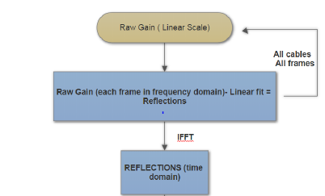

Figure 1: Flow chart presenting how we are getting reflections.

The Flowchart above describes the steps used to get the reflections for cables at 600 MHz. The purpose behind this experiment is to come up with a thermal model for the gain variations of coaxial cable used in analog chain. Raw Gain is calculated using:

$Gj \left(f\right)=\frac{Vij }{Vii }$

The gain calculated is in linear scale, for each frame and in frequency domain. Linear gain is unitless, as it is fraction of cross correlation of that channel with reference channel and autocorrelation of reference channel. The gain for 1 channel and single frame is mentioned in figure 2. The ripples in the plot represents multiple reflections in single channel. To begin with, we fitted linear line on gain plot and subtracted raw gain from fit. These reflections are due to multiple cables/connections in single channel and they are temperature dependent. Linear fit to raw gain has 2 parameters: Slope and Y-intercept. Our next step will be to check how these parameters are changing with temperature. Figure 5 shows the reflections in the cable at that instance, different colors represent different channels. These reflections are temperature dependent. Now we want to check how reflections are varying in a single channel over time, can we model them from weather data? Figure 6 shows reflections for one channel and 800 time frames. As mentioned above, that the cadence for these acquisitions was 10 minutes that makes 800 frames to be 5.5 days. It seems that the curve follows each other fairly well. But there might be some structure present in them that we are not seeing in this plot. To see that structure, we picked from figure 6 as reference and subtracting it from other curves, shown in figure 7. If we slice the data, i.e. pick one frequency and see how much these residuals of reflections are varying at that frequency. Figure 8 shows these residual reflections for 4 different frequencies. Black curve in this plot represent Air temperatures for that period. Note, we are using outside temperature. It seems that ripples in gain are driven by temperature. There seems to be some lag between both curves. To see how we are doing at other frequencies we sliced figure 7 at all frequencies and plotted them against time, we get figure 9. Two black curves here represent scaled Air temperature data.

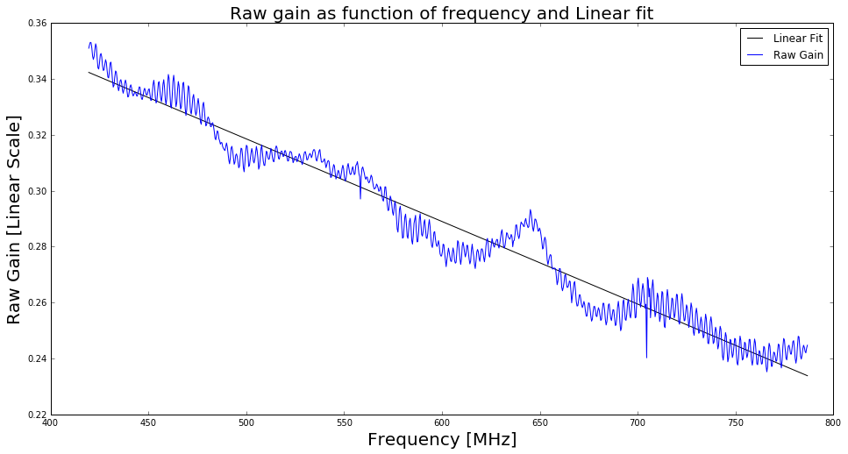

Figure 2: Raw gain as function of frequency for single channel and single time frame. The linear fit for the plot, in black line represents direct component of signal. If we subtract gain from fit, we will get reflection in this channel for this period. We want to check if we can model the reflections and the linear fit as function of temperature. There are two parameters for this linear fit: Slope and Y-Intercept, in later plots we will be checking how are these parameters varying with time. If they are, how closely are they following temperature. There are two parameters for linear fit, Slope and Y-intercept. We want to check how these parameters are varying with Air Temperature.

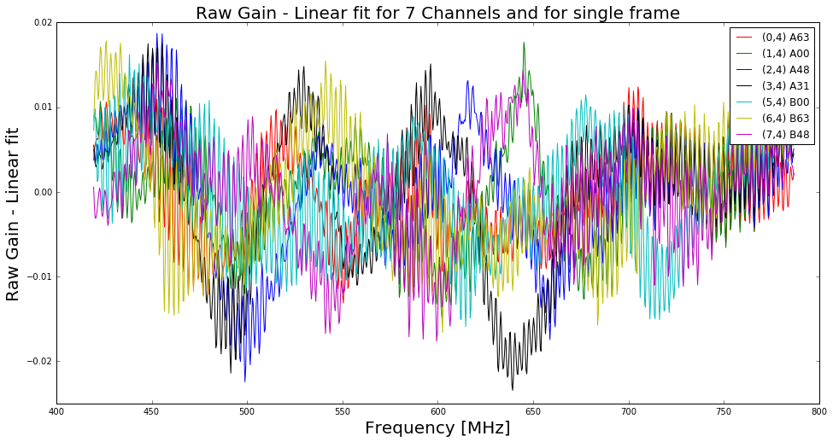

Figure 3: Residual of Raw Gain and Linear fit as function of frequency for 7 channels and single period/frame. In other words, these are reflections in 7 different channels for a time. The reflections in each cable seems to be different from each other.

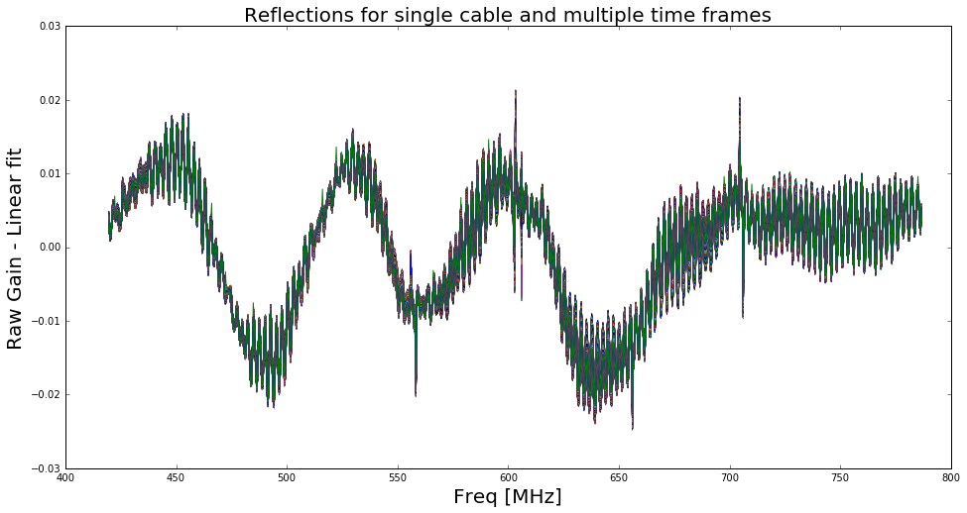

Figure 4: Reflections for single cable and 800 time frames, roughly 5.5 days. The curves look like following each other, but there might be some small scale structures present which we are not bale to catch here.

To see the small scale structures present in Figure 6, we subtracted one curve from other curves.

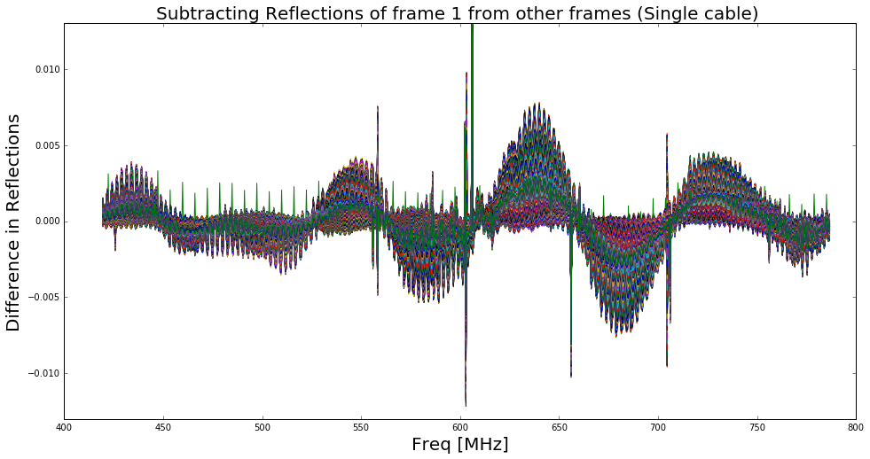

Figure 5: Picking one curve from figure 4 as reference and subtracting it from other curves. This is done to check how much structure is left in the reflections for different times. If we slice the data, i.e. pick one frequency and see how much reflections are varying at that frequency.

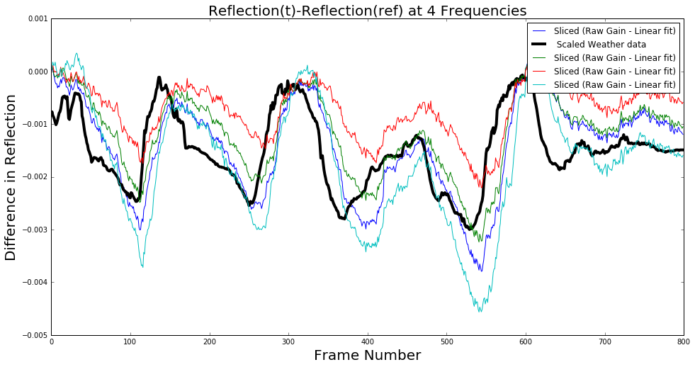

Figure 6: Slices of figure 5 at 4 different frequencies plotted against time. The four frequencies are: f1= 478 MHz (Cyan curve), f2= 578 MHz and 2 adjacent frequencies to f2. The black curve is scaled air temperature, we are using the outside temperature. It seems that ripples in gain are driven by temperature. There seems to be some lag between both curves.

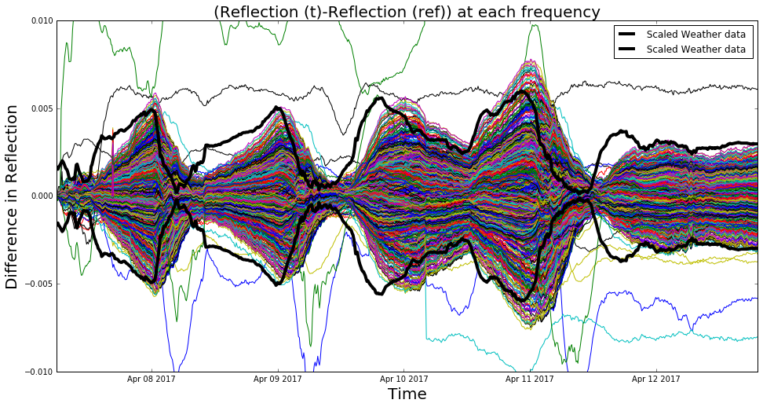

Figure 7: Difference in reflection for different frequencies. There seems to be some lag between temperature curve and residual reflections for all frequencies. There are different cables used in the experiment for a single channel. There is high possibility that the temperature of 2 m cables in the vestibule is not same as the air temperature, represented by black curve. If we separate the reflections and model them separately, we can get better thermal model.

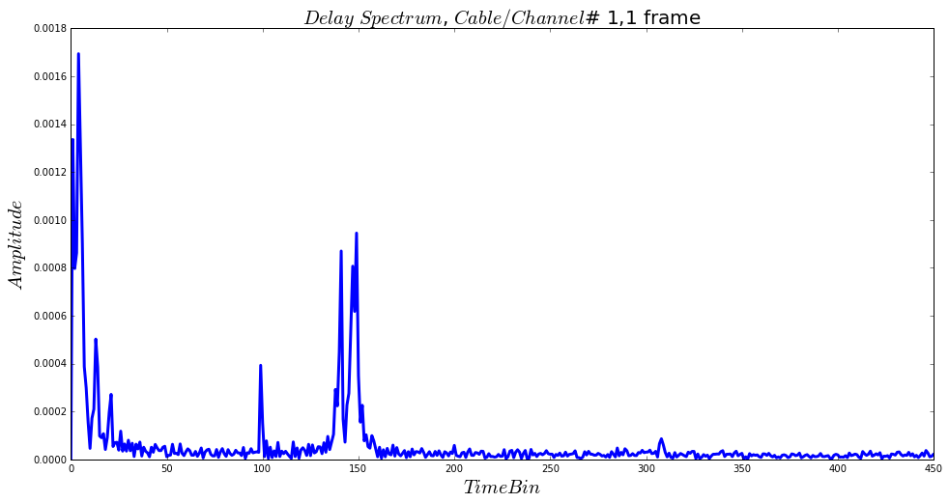

Figure 8: Delay Spectrum for Single Cable/Channel and Single frame. We see that there are few peaks in the spectrum. Peaks in lower side (left) are due to reflections in shorter cable and peaks in the middle are due to long cables. Separating them and monitoring them, how they changes with time (temperature), we might get a thermal model for these reflections.

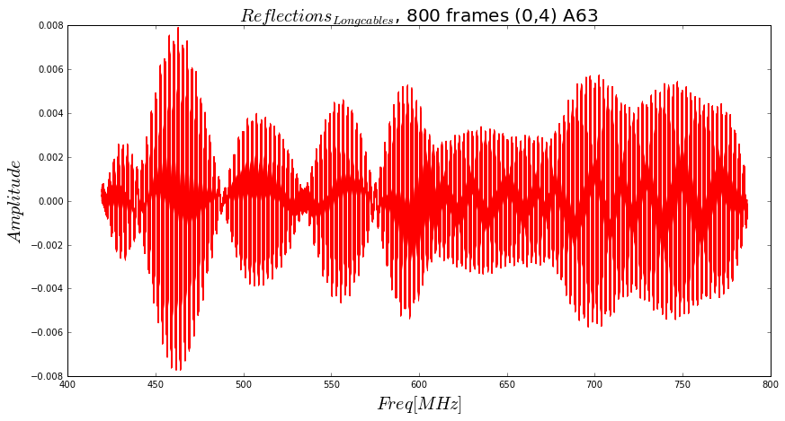

Figure 9: Reflections due to long cable present in experimental setup for single channel, (0,4) focal line number A63, each curve represents single frame. There are total of 800 frames, roughly 5.5 days of data. There is some common structure present here. (Figure 10) To see that structure we are subtracting one curve (reference) from all the other curves and then slicing it over frequency.

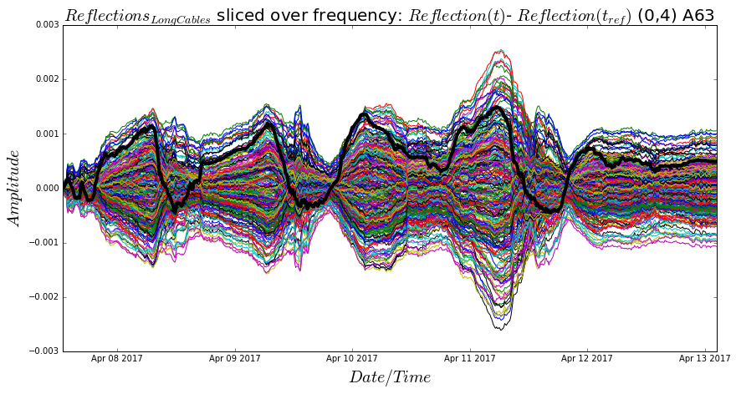

Figure 10: Reflections due to long cables for single channel, (0,4) focal line number: A63, sliced over every frequency. Each curve in the plot represents one frequency and there are total of roughly 950 curves. The black curve in each plot represents scaled air temperature. It is clear from the curve that the reflections due to short cables can be modelled using air temperature. Note: While doing this experiment we didn’t have any thermometry at the focal line/vestibule or inside the hut.

6 plots below represent reflections due to 6 different channels, mentioned in the title, sliced over frequency. Again, in each plot there are roughly 950 curves, representing different frequency.

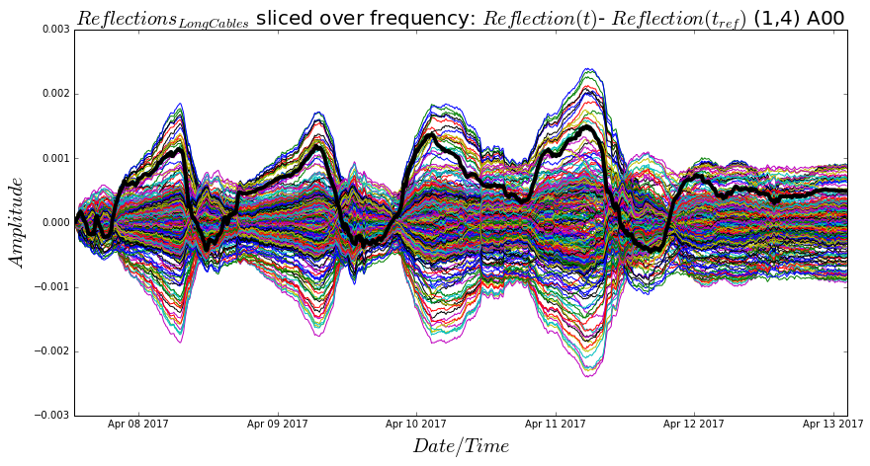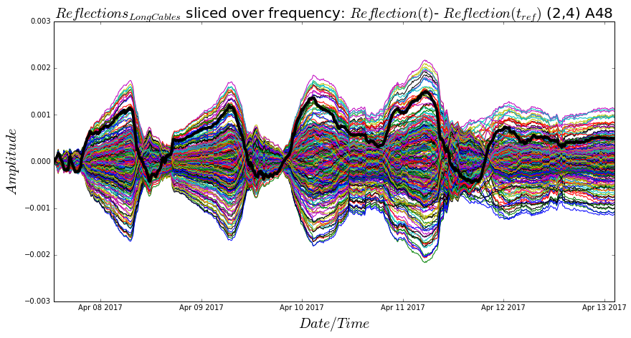

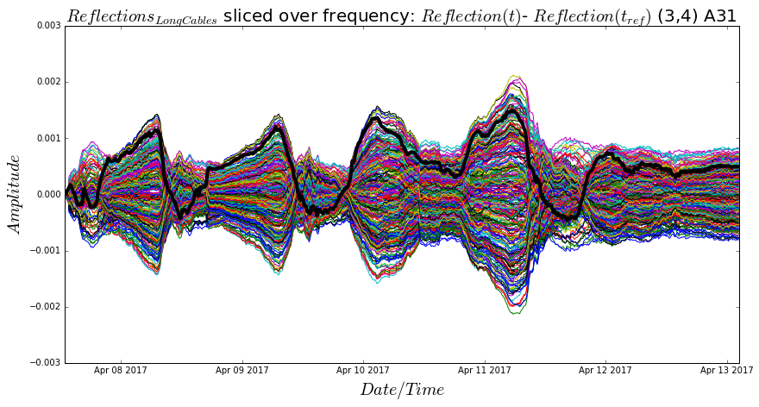

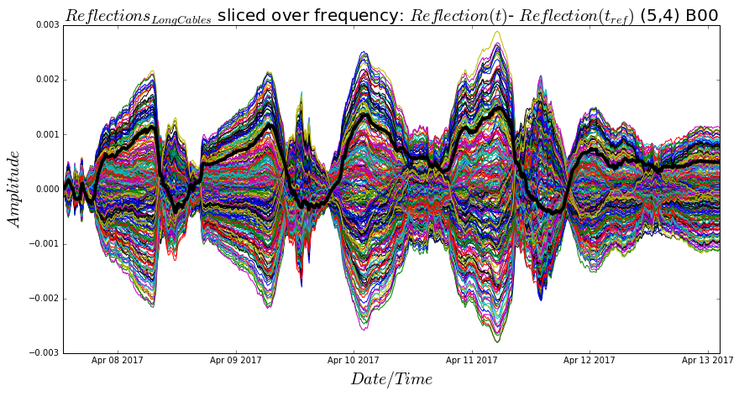

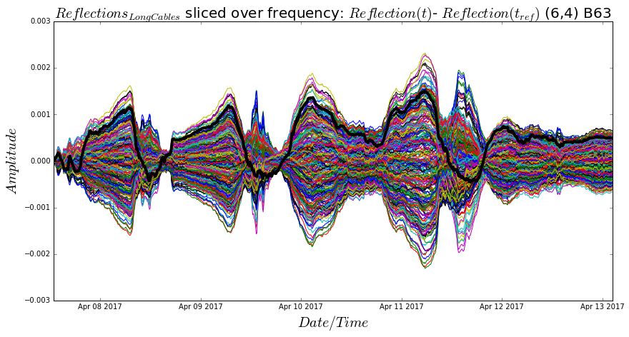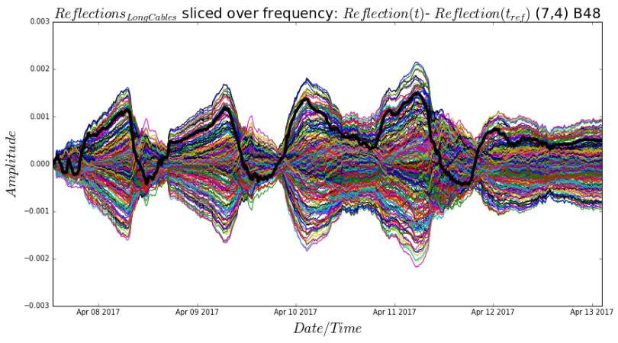

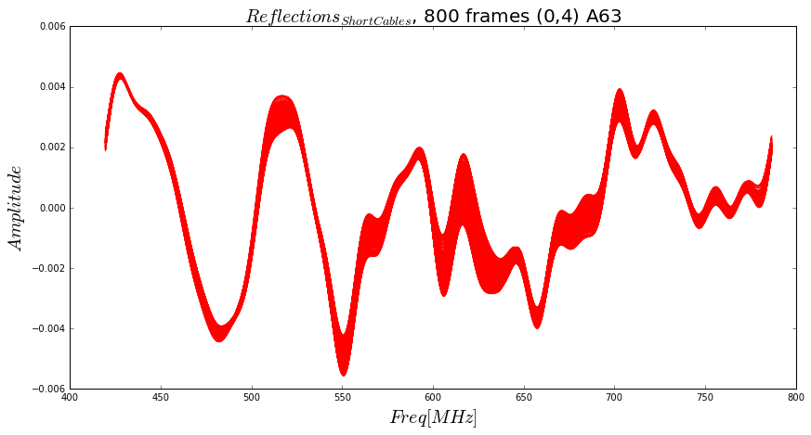

Figure 11: Reflections due to Short cable present in experimental setup for single channel, (0,4) focal line number A63, each curve represents single frame. There are total of 800 frames, roughly 5.5 days of data. There is some common structure present here. (Figure 12) To see that structure we are subtracting one curve (reference) from all the other curves and then slicing it over frequency.

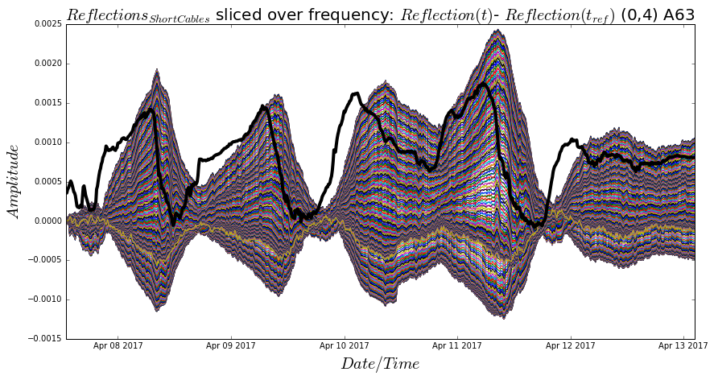

Figure 12: Reflections due to short cables for single channel, (0,4) focal line number: A63, sliced over every frequency. Each curve in the plot represents one frequency and there are total of roughly 950 curves. The black curve in each plot represents scaled air temperature. There is a lag between the air temperature curve and the other curves, the short cables are in vestibule, vestibule temperature might be different from the temperature outside. Note: While doing this experiment we didn’t have any thermometry at the focal line/vestibule or inside the hut. For this analysis we are creating proxy for vestibule temperature, explained later in analysis. The 6 plots below, represent reflections due to 6 different channels, mentioned in the title, sliced over frequency. Again, in each plot there are roughly 950 curves, representing different frequency.

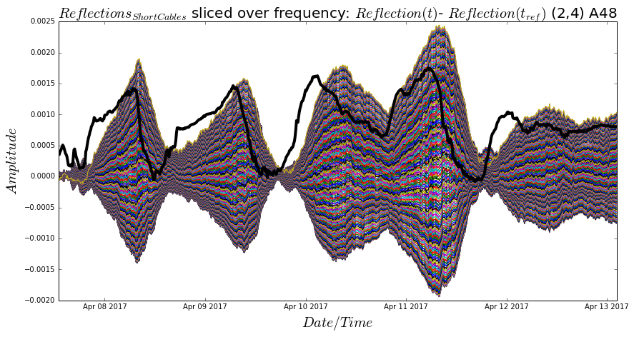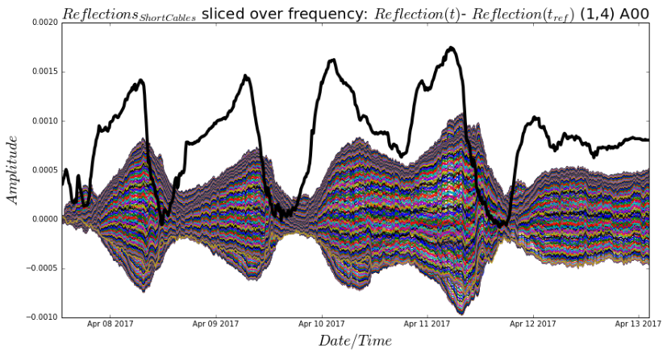

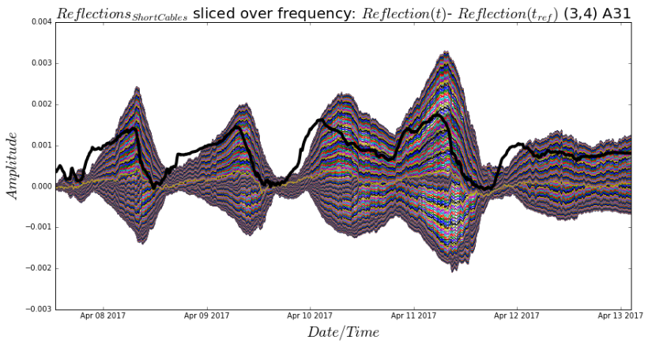

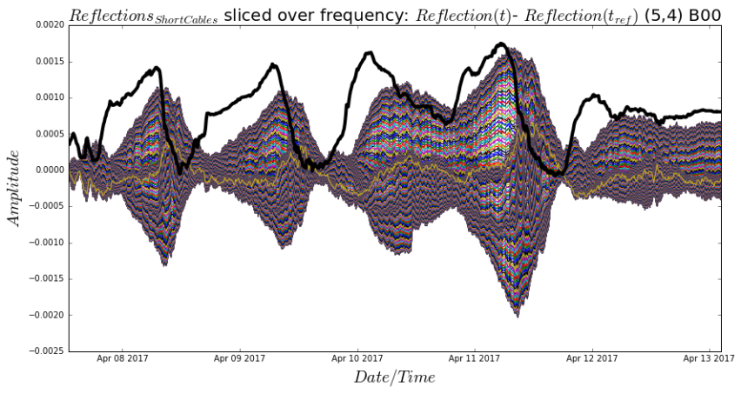

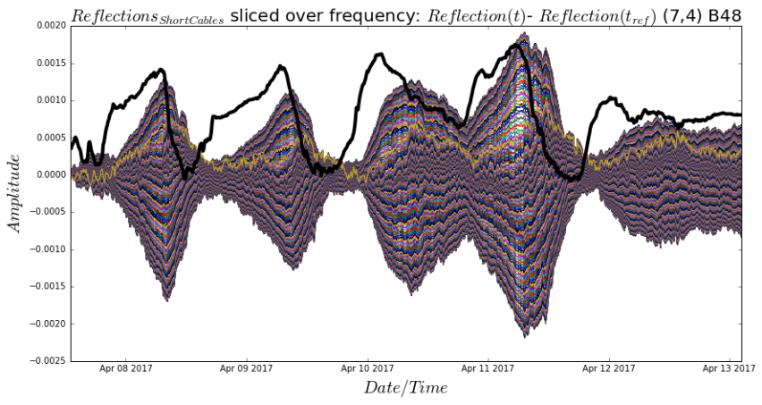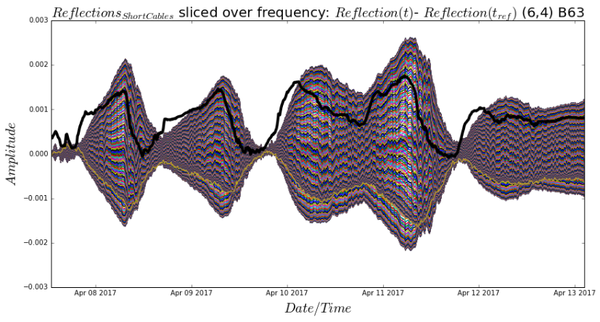

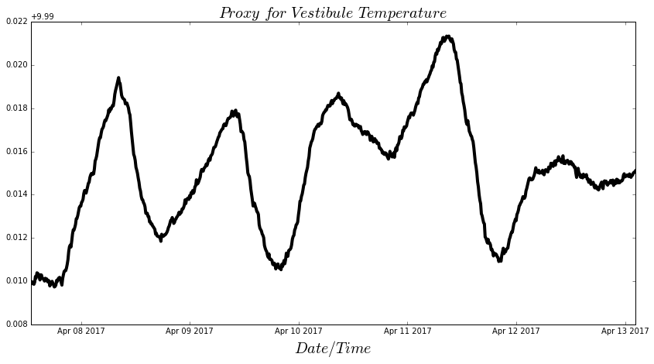

Figure 13: Taking 5 curves from figure 12 and averaging them, we are taking it as the proxy for vestibule temperature, while modelling the reflections due to short cables, we are using this Temperature (Proxy).

As explained in figure 2, we are first doing the linear fit for raw gain for each day. There are two parameters for the fit, slope and y-intercept. These parameters are time dependent.

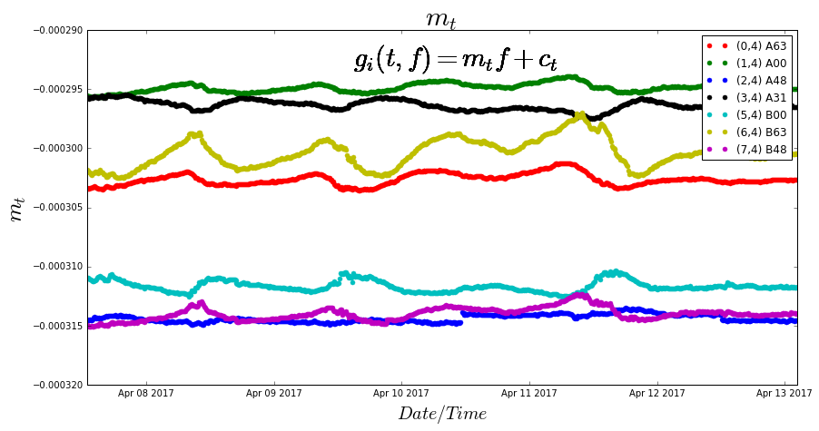

Figure 14: Figure represents the slope for linear fit (refer to figure 2) for each channel, shown in different colors. The fractional change in this parameter is very small hence we are taking this parameter as constant, i.e. a single value for each channel for all days.

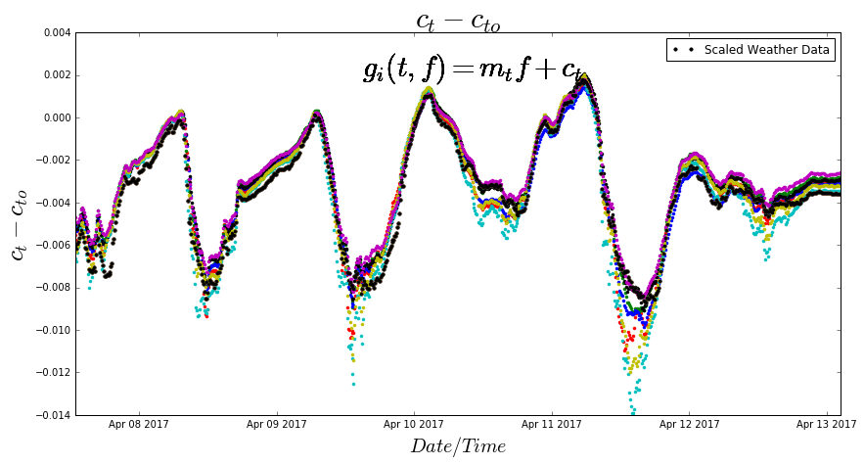

Figure 15: Scaled y-intercept parameter for each channel, represented in different color. The black curve represents scaled air temperature. In our analysis, I’m referring linear fit as the direct component of the signal. It seems that the y-intercept parameter is following the temperature closely.

**Model fitting parameters:**

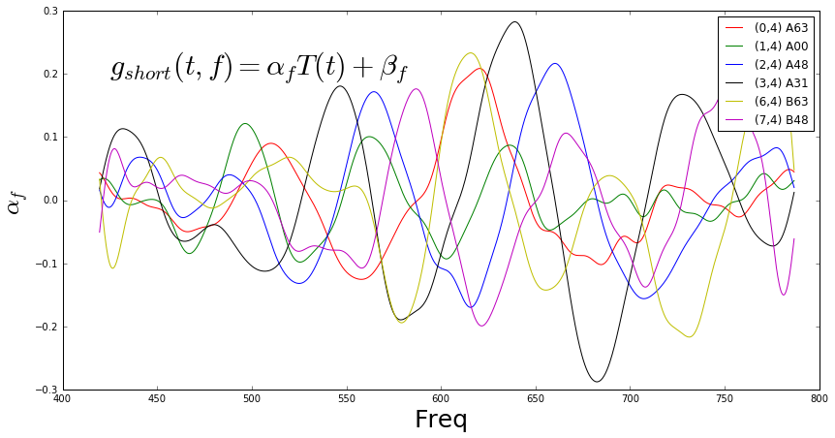

Figure 16: Parameter ‘αf’ used in thermal model for short cable reflections. Different curves in the plot are for different channels. Note, the Temperature used here is proxy for vestibule temperature. While this experiment was running, we didn’t have the thermometery installed in the vestibule or RF room.

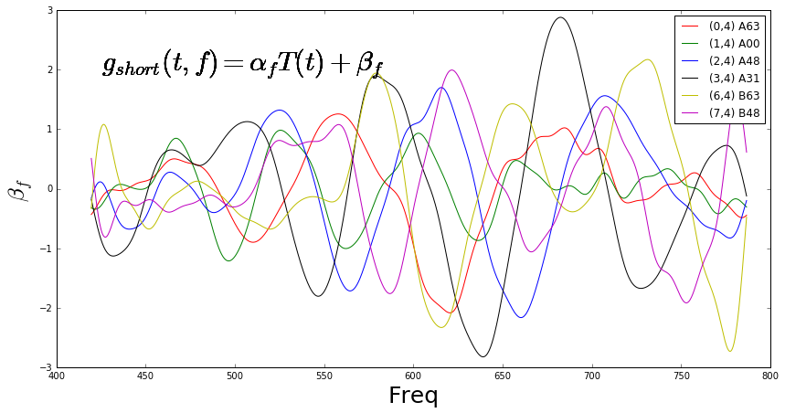

Figure 17: Parameter ‘βf’ used in thermal model for short cable reflections. Different curves in the plot are for different channels.

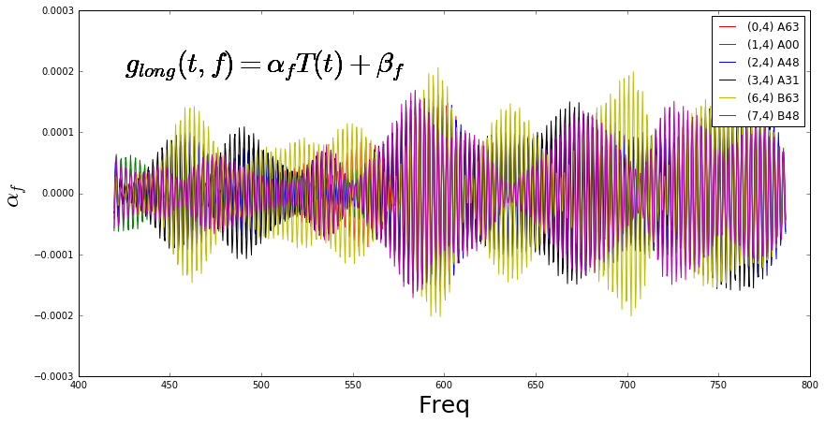

Figure 18: Parameter ‘αf’ used in thermal model for long cable reflections. Different curves in the plot are for different channels. Note, the Temperature used here is Air temperature. While this experiment was running, we didn’t have the thermometery installed in the vestibule or RF room.

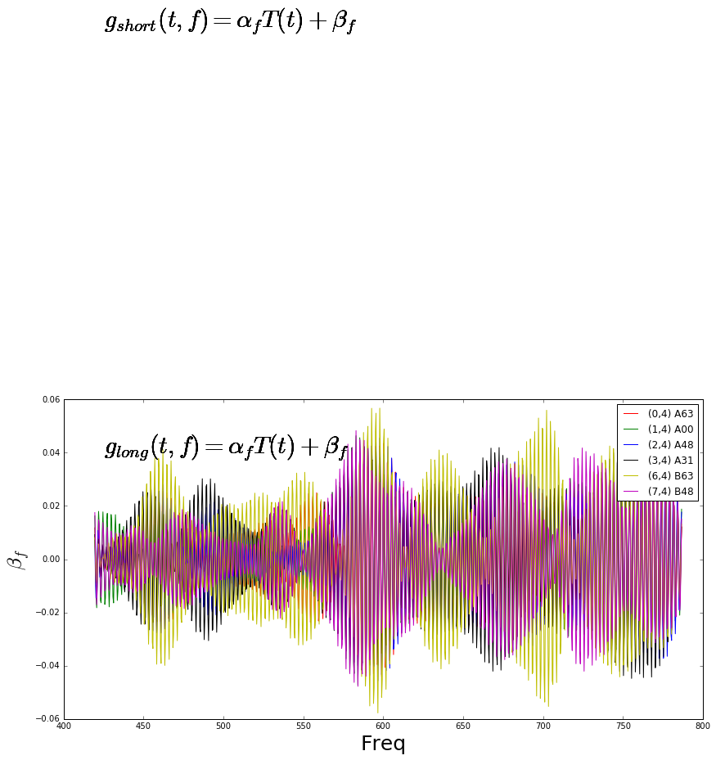

Figure 19: Parameter ‘βf’ used in thermal model for long cable reflections. Different curves in the plot are for different channels.

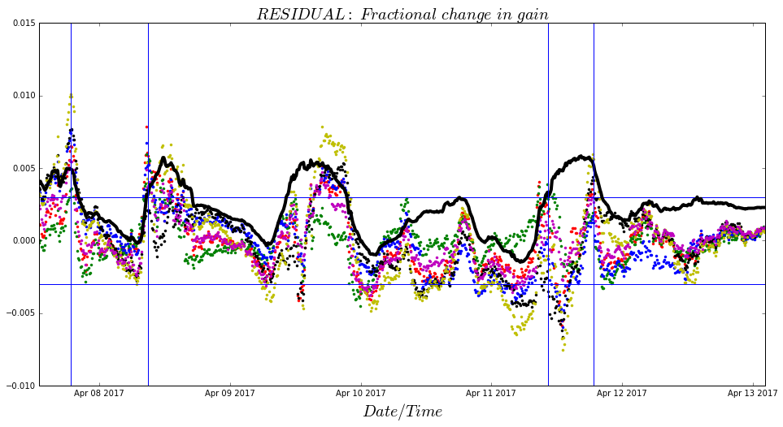

Figure 20: Residual for 6 channels @ 600 MHz, black line is scaled air temperature.